MODULE 4 – INTRODUCTION TO DBMS

LAB EXERCISES

15. SQL Triggers
Lab 1.
Create a trigger to automatically log changes to the employees table when a new employee is added.
Ans.
1. create log table
CREATE TABLE employee_log (log_id int, emp_id int, emp_name varchar(255), asction_type varchar(255), action_time TIMESTAMP DEFAULT CURRENT_TIMESTAMP);

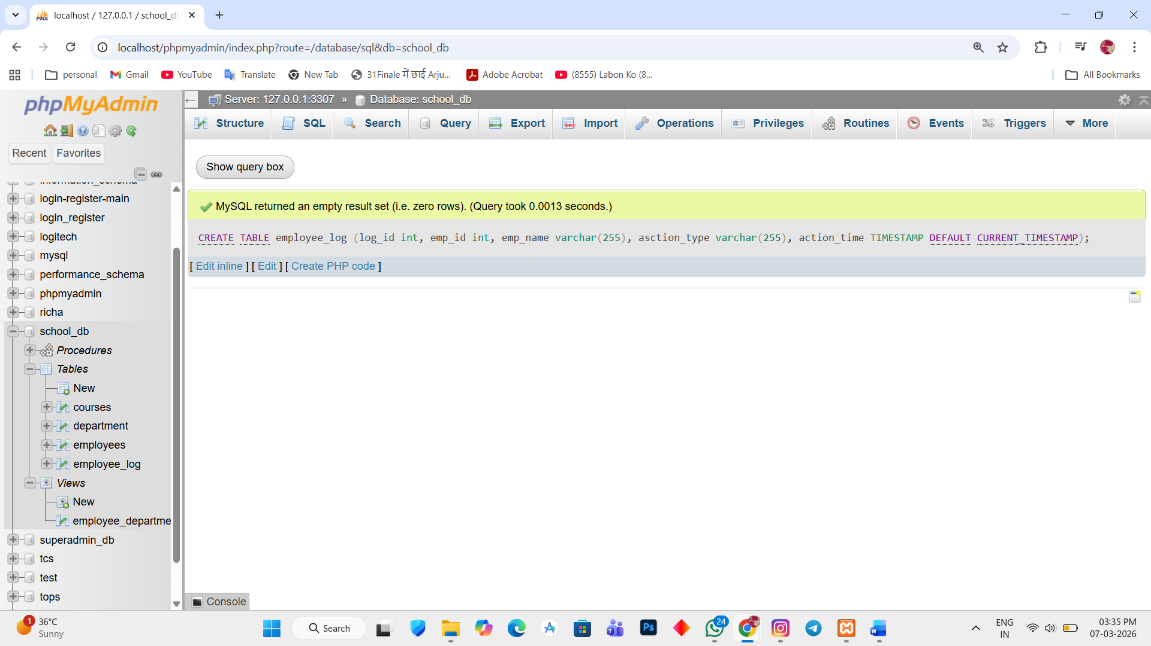

2. create trigger
DELIMITER //

CREATE TRIGGER after_employee_insert AFTER INSERT ON employees FOR EACH ROW

BEGIN

INSERT INTO employee_log(emp_id, emp_name, action_type) VALUES (new.emp_id, new.emp_name, 'NEW EMPLOYEE ADDED');

END //

DELIMITER ;

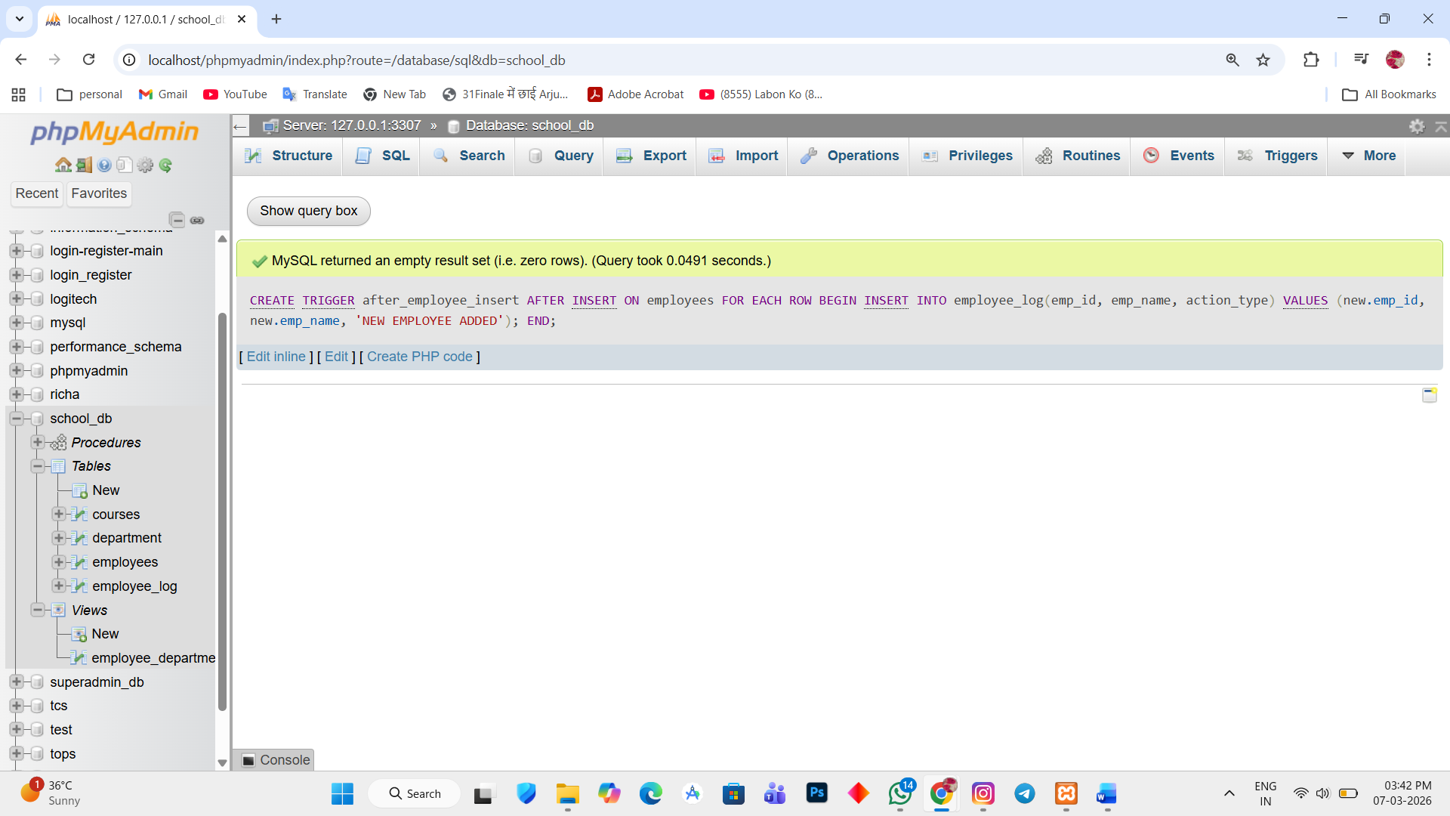

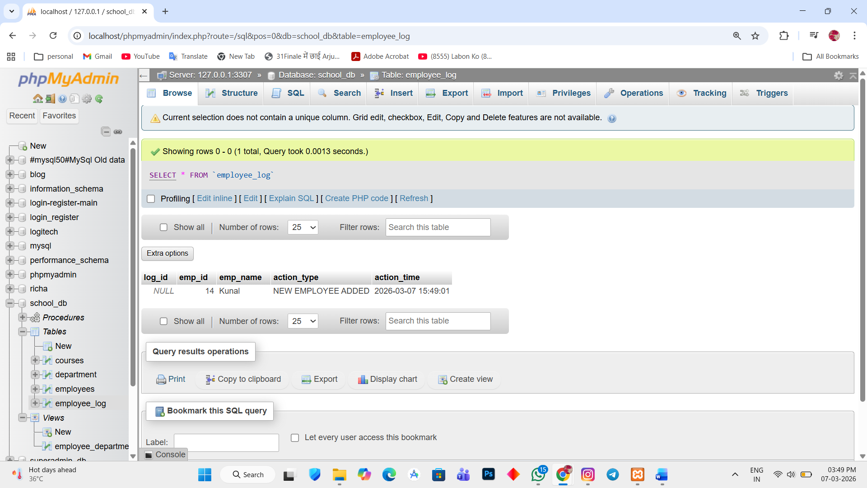

Lab 2.
Create a Trigger to update the last_modified timestamp whenever an employee record is updated.
Ans.
Add last_modified column
1. ALTER TABLE employees ADD last_modified TIMESTAMP;
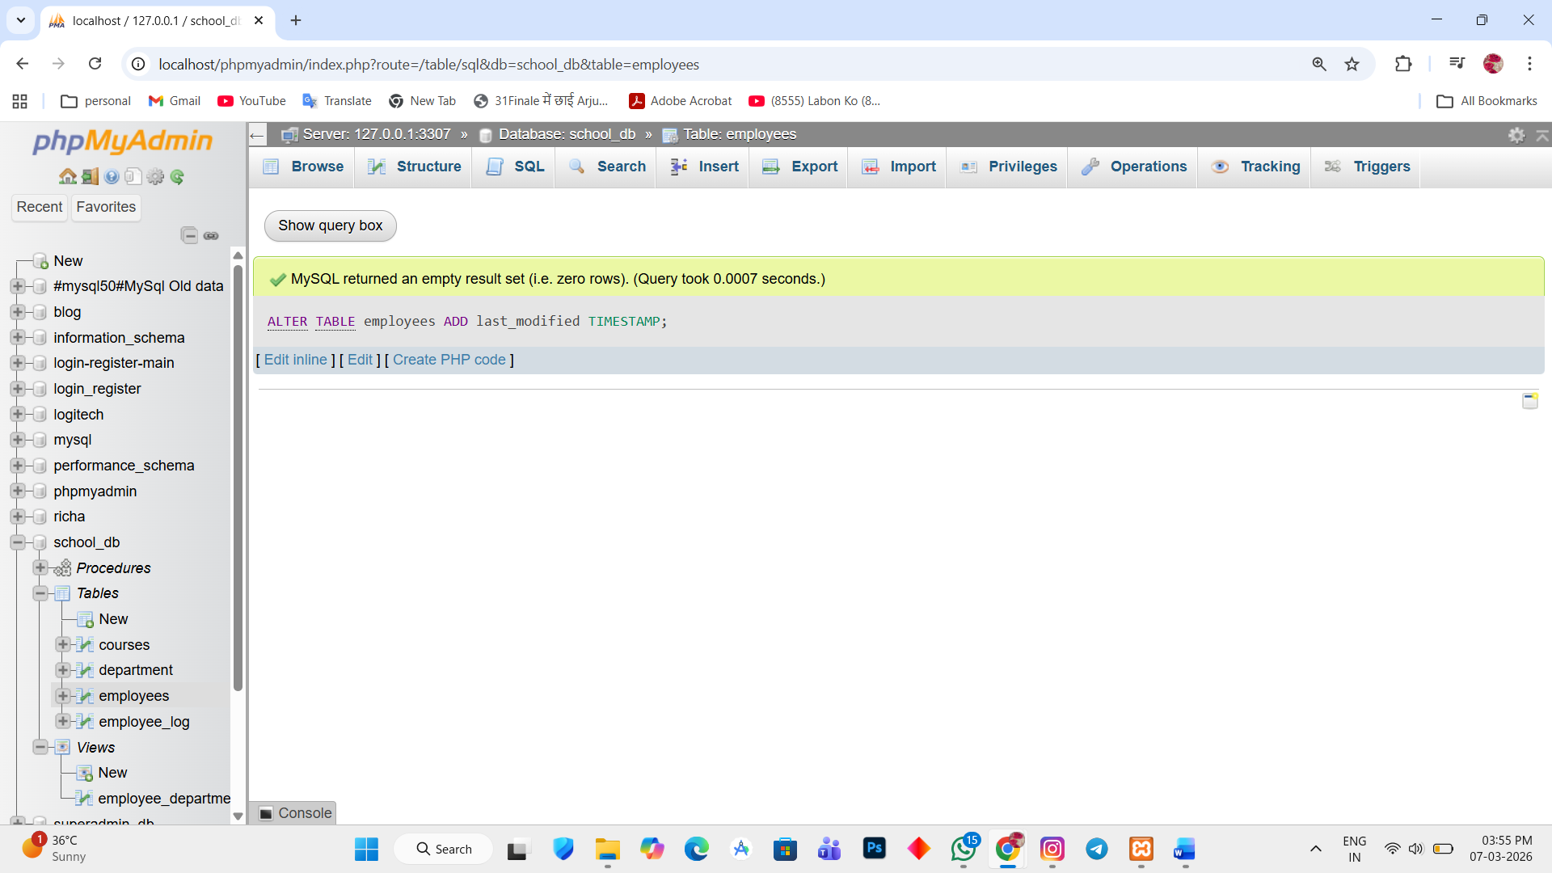

2. create trigger
DELIMITER //

CREATE TRIGGER update_last_modified BEFORE UPDATE ON employees FOR EACH ROW

BEGIN

SET new.last_modified = CURRENT_TIMESTAMP;

END //

DELIMITER ;
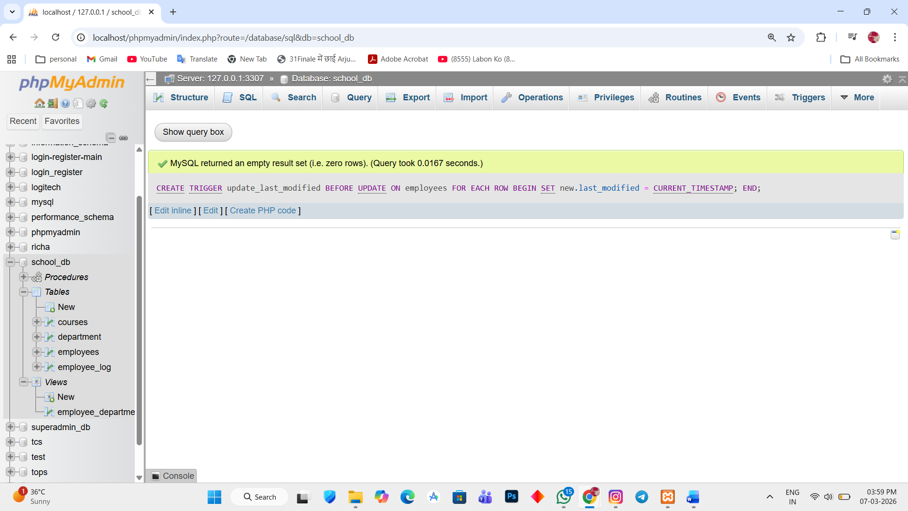

3. TEST TRIGGER
UPDATE employees SET salary = 75000 WHERE emp_id = 1;
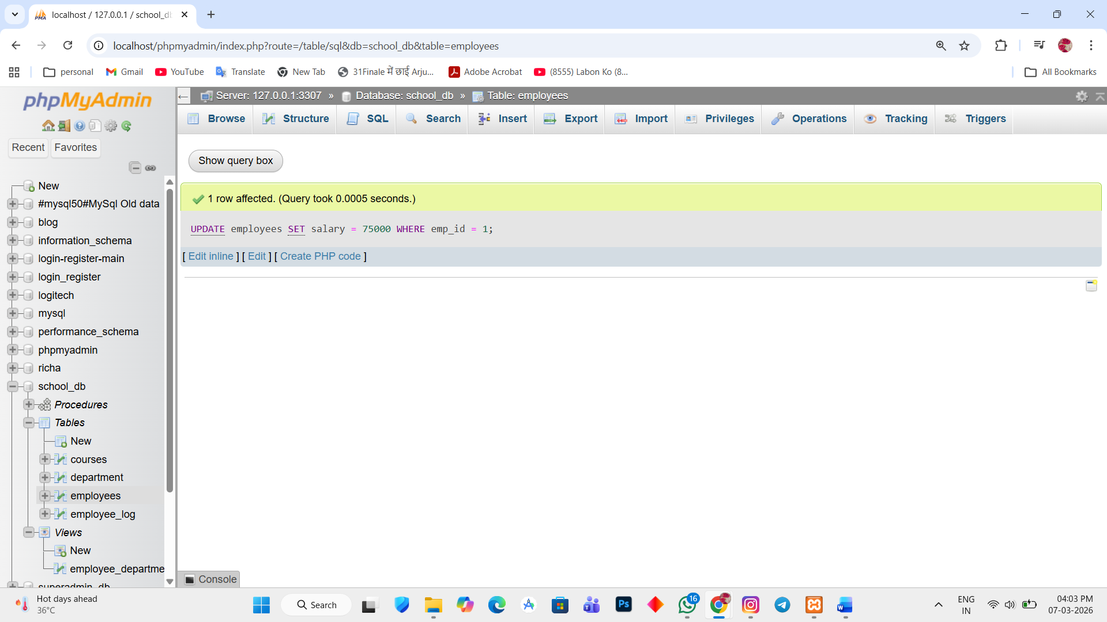

4. check trigger
SELECT emp_id, emp_name, last_modified
FROM employees;
